Good Shepherd Breakfast and After School Club – Nash Mills

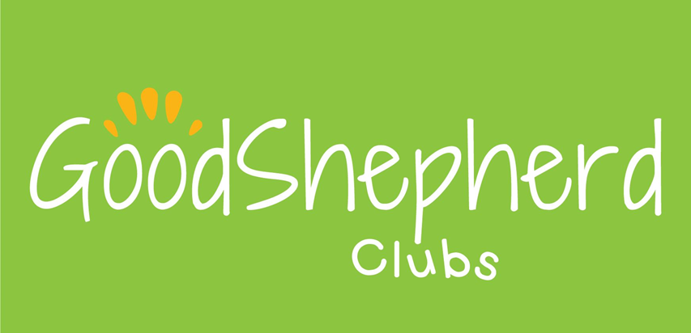

COVID-19 precautions information for parents/carers.

September 2020

Dear Parents/Carers,

The purpose of this document is to give you an outline of the changes we are making in September to make the Club as safe as possible for your children and our staff.

We would be grateful if you could discuss what is covered here with your children before they return to the Club in order to prepare them for some of the changes we have made and reassure them that the Club is a safe place for them to be.

If you have any questions about anything we’ve covered here (or anything else) please don’t hesitate to get in touch.

Pods

* We will be working on the same pod system as the school with 3 pods – Reception Years1/2/3 and Years4/5/6. All pods will be kept socially distanced from each other at all times, unless there is an emergency, in which case the safety of children and staff will take priority over maintaining social distancing. Each pod will have their own allocated area inside and an allocated area outside for them to play in. Each pod will also have their own selection of play resources/equipment which will be cleaned regularly. If equipment or resources are to be moved between groups we will make sure they are either cleaned or ‘quarantined’ for 72 hours between uses.

Dropping off/picking up

* As the school entrance is a potential spot where coronavirus could be spread, we are asking parents to drop off and collect their children at the staff car park gate. You can call the **Club drop off/collection number (07568622972)** to let us know that you have arrived to drop off or pick up your child. There is also a doorbell that you can ring. It is a good idea to call us when you are on your way so that we can get your child ready for you. Simply state your full name, your child’s full name and the club password when you call. This number is for drop off/collection only, please continue to use the other contact number (07534896953) for all other enquiries.
* To limit risk of infection parents/carers will not currently be allowed to enter the school building, so we will collect your child from you or drop them to you at the staff carpark gate.
* We would also ask that only one adult come to drop off/pick up a child, that you maintain social distancing at all times if there is more than one family waiting at the gate.
* Where possible can you please avoid lift sharing when travelling to/from school to help maintain appropriate social distancing.
* As you will not currently be able to enter the building, a member of club staff will sign your child in/out for you.

Playworkers dropping off/picking up children from their classes

* Staff will be taking children to their classrooms in the mornings at the designated time for their pod to help ensure that social distancing is maintained.
* In the afternoons we will be providing the school with a register, with the names of the children we are expecting from each class. Key stage 2 children will make their way to the dining hall, and we will collect key stage 1 children from their classrooms a pod at a time.

Hand hygiene

* All children and staff will be expected to sanitise their hands on arrival at a session.
* We will be providing extra opportunities for hand washing/sanitising as appropriate, including, but not limited to: after playing outside and after coughing or sneezing.
* When lots of children will be needing to wash their hands at the same time (e.g. before afternoon snack) each pod will have their own ‘handwashing station’ with soap, water and paper towels.

Respiratory hygiene

* We will be promoting the ‘catch it, bin it, kill it’ strategy,
* Each pod will be provided with a box of tissues and a lidded container to dispose of them.
* After using a tissue/coughing/sneezing children will be asked to wash/sanitise their hands.

Social distancing

* We are putting various strategies in place to help ensure social distancing between pods.
* If a child is struggling with maintaining/understanding social distancing we will have a chat with them explaining what it is, and why it is important.
* If the child still struggles, we will inform the child’s parent/carer and ask them to have a talk with their child about it.
* If the child is still having difficulty maintaining social distancing after this, we may have to consider suspending the child’s place for now in order to ensure the safety of the other children and staff.
* Due to the need for social distancing we will not currently be able to offer active play in the hall (except on rare occasions when only children from one pod are present). Future Stars coaches will, however, still be visiting us on a Tuesday/Wednesday/Thursday morning to provide additional staffing.

Cleaning

* Equipment/resources/tables etc will be cleaned regularly.
* We are working with the school to establish any additional cleaning we will need to do (toilets we have used/touch points etc).

Breakfast/afternoon snack

* We will still be offering breakfast and an afternoon snack as before. For now though, children will be asked what they want, and the food will be prepared by staff and taken to each child for them to eat at their pod table (or to have as a picnic outside).
* All washing up will also currently be done by staff to ensure it is done to a good standard.
* We are asking that all children bring in their own drink bottles as water fountains etc are unlikely to be available. These will be able to be refilled as needed.

Activities

* We are still working out the best way of approaching the adult led activities we normally provide. We are hoping that we will still be able to do this (although some activities, like cooking, are unlikely to be practical at this time). For the first couple of weeks or so, however, it is likely that there will not be any adult led activities whilst we focus on implementing our new arrangements and make sure that both staff and children are familiar and comfortable with them.

Toys from home

* We are asking that children do not bring in toys from home until further notice.

Children attending multiple settings/groups

* In order to reduce the risk of virus transmission as much as possible, we ask that, where possible, you limit the number of settings your children attend.

Temporary/partial closure

* There may be times when we have to temporarily close the club, in full or in part. This could be because of advise from Hertfordshire County Council or Public Health organisations in order to safeguard the children in our care.
* If this does become necessary, we will inform you as soon as possible.

What we will do if a child shows symptoms of coronavirus.

* If your child shows any of the main symptoms of COVID-19 (new persistent cough/fever/loss of taste or smell) we will isolate them (ideally to a different room, but at least 2m away from the other children), phone you, and ask you to collect your child as soon as possible.
* Whilst we wait for you to arrive your child will be supervised by a member of staff, who will remain at least 2m away from them at all times if possible. (If this is not possible, the staff member will wear appropriate PPE as specified in government guidelines).
* Your household should then self-isolate according to current guidance, or until your child receives a negative test for COVID-19. Your child will not be allowed to return to the club until this has taken place.
* You can request a coronavirus test either through the NHS website (<https://www.nhs.uk/conditions/coronavirus-covid-19/testing-and-tracing/get-a-test-to-check-if-you-have-coronavirus/>) or via phone using the NHS 119 service.
* If we send a child home with suspected symptoms we will also inform the school.

Self-isolation guidance

* We expect all families to follow the current government guidance re: self-isolating if someone in the household is showing COVID-19 symptoms, has tested positive or has recently returned from certain other countries (Government information about international travel can be found here: <https://www.gov.uk/foreign-travel-advice>). (The NHS page giving information about when and how to self-isolate can be found here: <https://www.nhs.uk/conditions/coronavirus-covid-19/self-isolation-and-treatment/when-to-self-isolate-and-what-to-do/>)
* If your child is ill or is starting to develop symptoms please do not send them in to the club.
* If your child will not be attending a session because they are ill or self-isolating, please let us know asap.

Government documents

* The government have produced some guidance for parents and carers of children attending out-of-school settings during the coronavirus (COVID-19) outbreak, which you may wish to read. The link to find it is: <https://www.gov.uk/government/publications/guidance-for-parents-and-carers-of-children-attending-out-of-school-settings-during-the-coronavirus-covid-19-outbreak/guidance-for-parents-and-carers-of-children-attending-out-of-school-settings-during-the-coronavirus-covid-19-outbreak>

*Please note that all arrangements are subject to change depending on government guidance or a change in circumstances. If we make any significant changes to what is written here we will inform you as soon as possible.